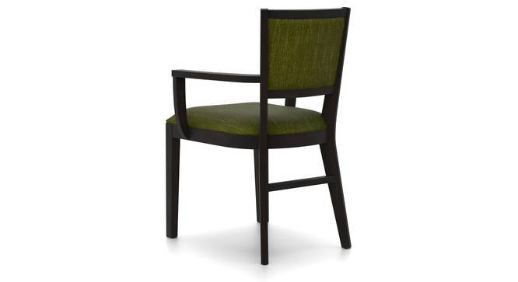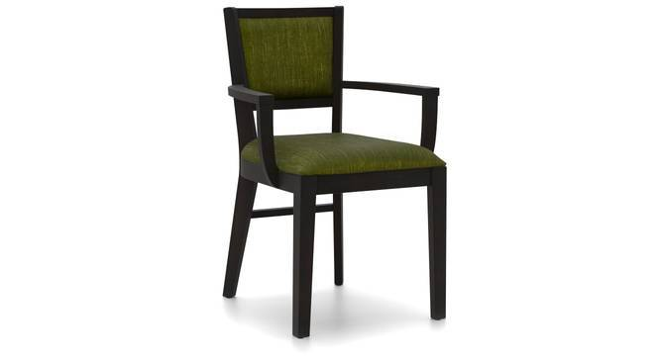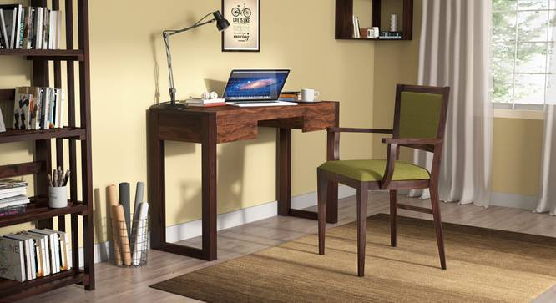

* The Aurelio study chair comes in gorgeous olive & sandstorm fabric options and a rich mahogany finish,
* Designed to be used with solid wood study tables and in home offices, this chair brings with it a touch of class
* Use it at your desk, or as an accent piece, it works wonderfully as either.

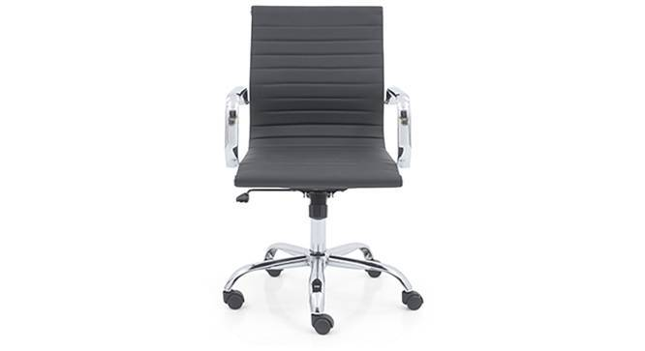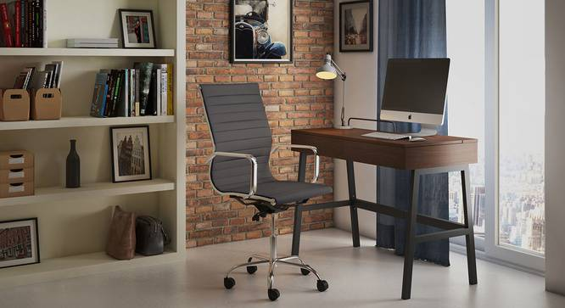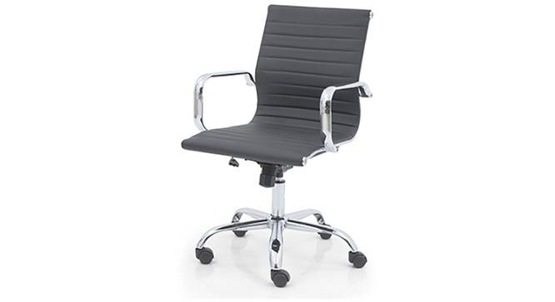

* Curves ahead! The Charles study chair is designed to mirror your spine, and the slight S shape supports your back comfortably, so you can work easy, all day (or night) long. Use it at your desk at work, at home, or use it in multiples in the conference room.
* The cushioned seat and back are comfortable and low maintenance

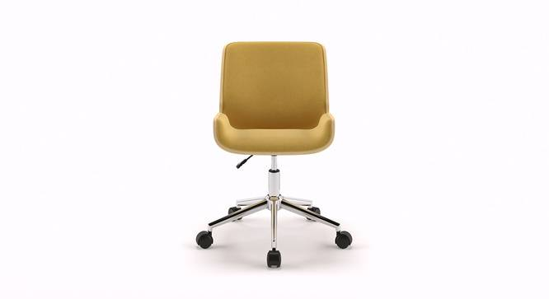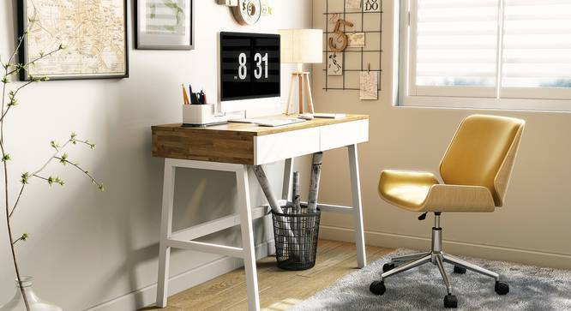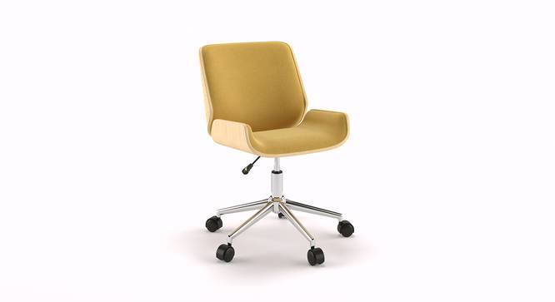\

* Is your study looking drab? The Abigail’s your antidote! This study chair is trim, clever, and quite the looker. The upholstered seat and adjustable height provide a comfy setting for long hours. The swivel base ensures easy movement, while the plywood frame adds class to the arrangement.
* Available in two colours
* The black variant is upholstered in leatherette, the yellow variant is upholstered in fabric